How do I create a profile/register?

Overview
The registration workflow gathers user profile information as well as data that is used to match advisees with advisors. Users can enter information manually or import most of the details by choosing the autofill with LinkedIn option.

From your University/School’s Firsthand URL select Get Advice
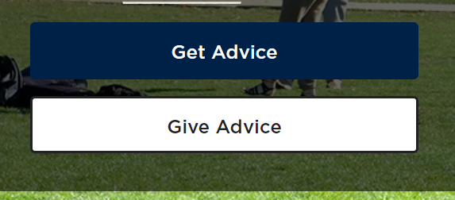
You may register using your LinkedIn account or manually by clicking the “No account yet? Register now” option at the bottom of the screen
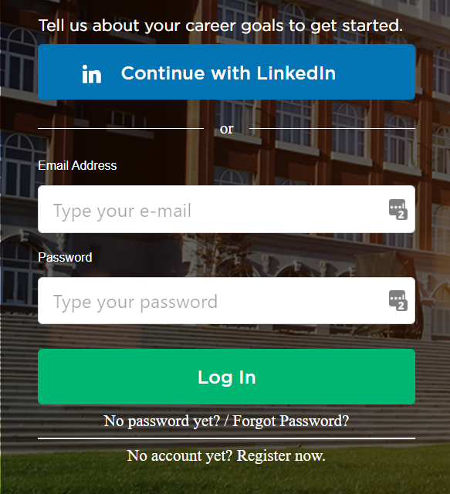

If using the Register Now option, the next landing page you will enter your email address and click SUBMIT
The following landing page is where you will create a Password and agree to the Terms of Service. Next, you will be prompted to verify your email address by going into the email that is sent and clicking the link.

Collected from All Users
- First and last name
- Email
- Phone number (optional, but recommended for text message reminders)
- Current location
- Profile photo (optional, but recommended)
- Graduation year
- Degree(s) and field of study
- Affinity groups (If enabled)
- Languages spoken

Collected from Mentees Only
- The number one thing they need help with
  - Options shown depend on the consultation type categories enabled
- Which specific things they could really use help with (choice of up to three)
  - Options shown depend on which consultation types are enabled within the category chosen in the step above
- Career Goals:
  - Cities in which they’d like to live in five years (choice of up to ten)
  - Industries they’re interested in (choice of up to ten
  - Employers they’d like to work for (choice of up to ten)
  - Roles they’re interested in (choice of up to ten)

Collected from Mentors Only
- Employment history
  - Titles
  - Employers
  - Employment dates
  - Locations
  - Industries
  - Roles
- Degrees from schools other than the one hosting the platform
- Consultation types they’d like to opt into
  - Options shown depend on which consultation types are enabled
- Times during which they’re generally available for consultations

