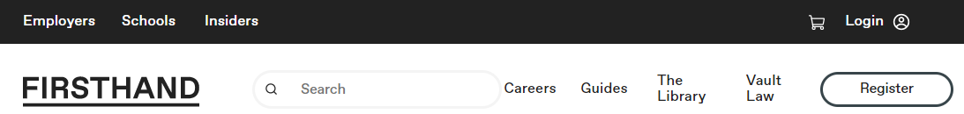

**Your Handy Quick Start Guide**

**We are delighted to announce that you now have unlimited access** to the trusted and comprehensive Firsthand career resource, to help you from start to end in your job or internship search!

Firsthand enables you to research employers and industries, gain career advice, and apply to jobs and internships. Whether you are just exploring possible career paths or are ready for an interview, Firsthand is your trusted resource.

Register using your Institution’s Firsthand URL.

Here’s what’s waiting for you, after registering.

1. **Explore tons of Vault Guides** on a wide variety of topics.
2. **Explore industries and watch Q&A videos by professionals** in various industries and fields.
3. **Investigate Vault ranked employers** with Vault Company and Internship Rankings.

Then select “Get Started” to set-up your account.

Career Advice that will prepare you

to land your perfect job.

Questions: Contact us at support@firsthand.co

Explore **verified employee and intern reviews**.